**WEEK-5**

**#1 Write a C++ program to enter elements in the array and display the array elements.**

This is the required code: 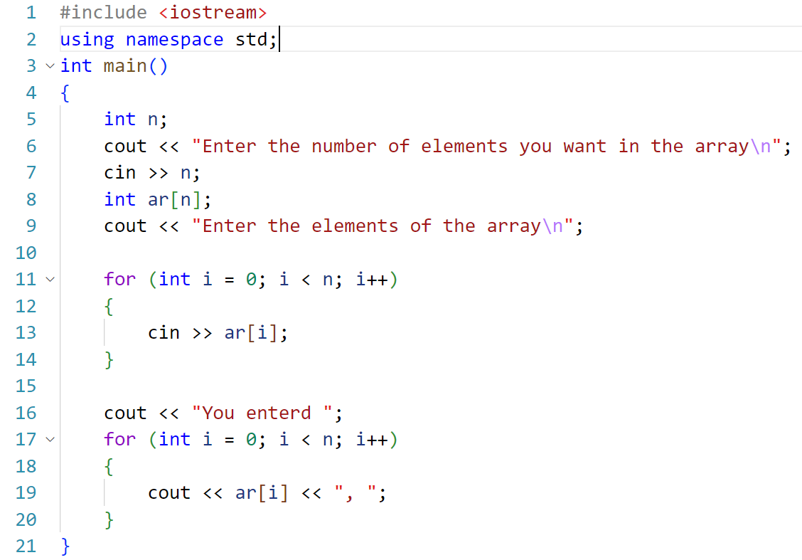And this is result: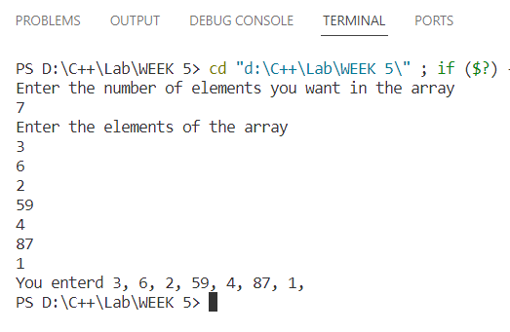

**#2 Write a C++ program to find the sum of the all-array element.**

This is the required code:

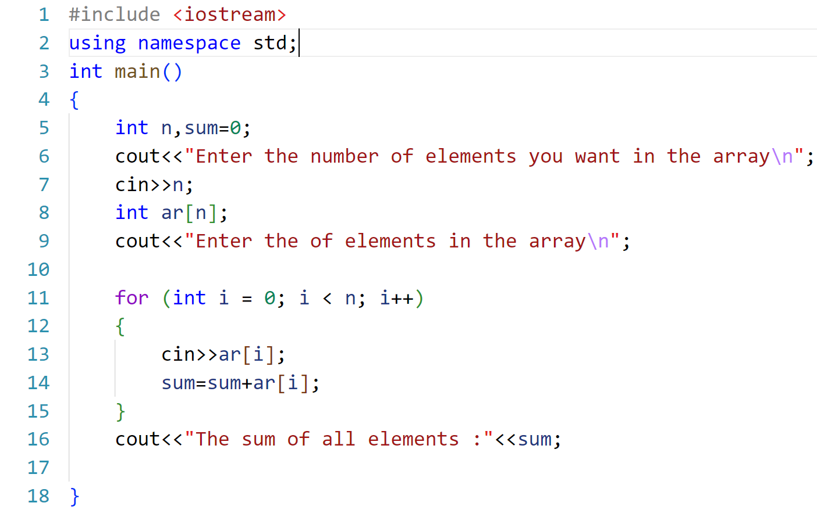

And this is result:

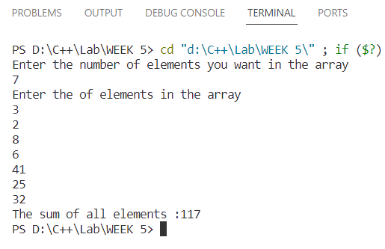

**#3 Write a C++ program to find the length of the array.**

This is the required code:

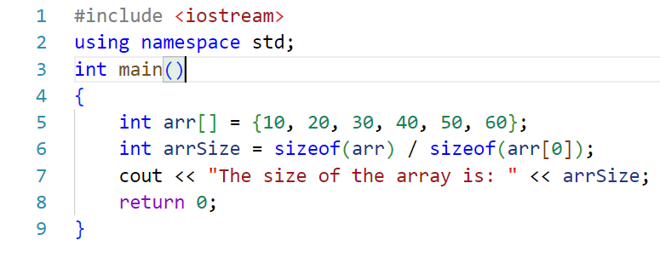

And this is output:

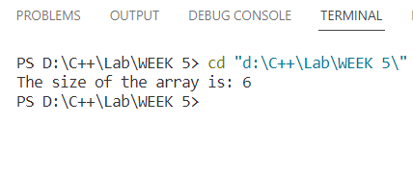

**#4 Write a C++ program to find the second-largest integer in a list of integers.**This is the required program:

#include <iostream>

using namespace std;

// finding the second largest number in the array : running

int findSecondLargest(int arr[], int size)

{

    int largest = arr[0];

    int secondLargest = arr[0];

    for (int i = 1; i < size; ++i)

    {

        if (arr[i] > largest)

        {

            secondLargest = largest;

            largest = arr[i];

        }

        else if (arr[i] > secondLargest && arr[i] != largest)

        {

            secondLargest = arr[i];

        }

    }

    return secondLargest;

}

int main()

{

    cout << "Enter the number of elements you want in the array: ";

    int n;

    cin >> n;

    int arr[n];

    cout<<"Enter the elements\n";

    for (int i = 0; i < n; i++)

    {

        cin>>arr[i];

    }

    int secondLargest = findSecondLargest(arr, n);

    cout << "The second largest element is: " << secondLargest << endl;

    return 0;

}

And this is the result of the program:

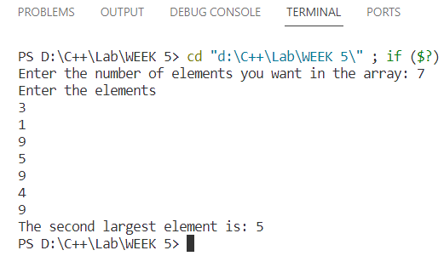

**#5 Write a C++ Program to reverse the position of the array element (Hint: First eminent to the last element.)**

This the required program:

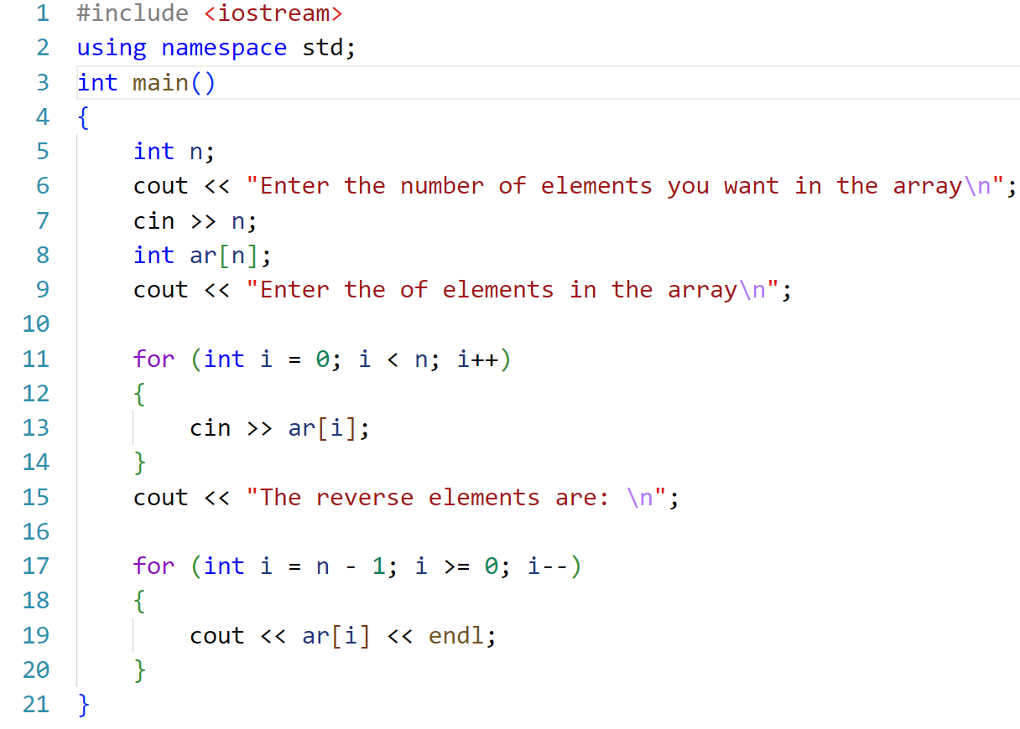

And this is the result:

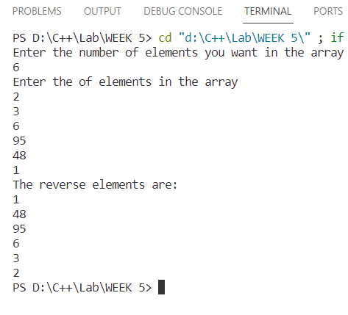

**#6 Write a C++ program to perform the following:**

**a. Addition of two matrices.**

**b. Multiplication of two matrices.**

#include <iostream>

using namespace std;

// addition and multiplication of two matrices: running

int main()

{

    int rows1, cols1, rows2, cols2;

    cout << "Enter the number of rows and columns of first matrix: ";

    cin >> rows1 >> cols1;

    int matrix1[rows1][cols1];

    cout << "Enter the elements of first matrix:\n";

    for (int i = 0; i < rows1; i++)

    {

        for (int j = 0; j < cols1; j++)

        {

            cin >> matrix1[i][j];

        }

    }

    cout << "Enter the number of rows and columns of second matrix: ";

    cin >> rows2 >> cols2;

    // checking condition for multiplication

    if (cols1 != rows2)

    {

        cout << "Invalid input! Number of columns of first matrix should be equal to number of rows of second matrix.";

        return 0;

    }

    int matrix2[rows2][cols2];

    cout << "Enter the elements of second matrix:\n";

    for (int i = 0; i < rows2; i++)

    {

        for (int j = 0; j < cols2; j++)

        {

            cin >> matrix2[i][j];

        }

    }

    // product logic

    int product[rows1][cols2];

    for (int i = 0; i < rows1; i++)

    {

        for (int j = 0; j < cols2; j++)

        {

            product[i][j] = 0;

            for (int k = 0; k < cols1; k++)

            {

                product[i][j] += matrix1[i][k] * matrix2[k][j];

            }

        }

    }

    // printing products

    cout << "The product of both matrices is:\n";

    for (int i = 0; i < rows1; i++)

    {

        for (int j = 0; j < cols2; j++)

        {

            cout << product[i][j] << "  ";

        }

        cout << "\n";

    }

    // checking condition for addition

    if (rows1 != rows2 || cols1 != cols2)

    {

        cout << "Sum is not possible, the number of rows and columns of both matrices should be same\n";

        return 0;

    }

    // sum logic

    int sum[rows1][cols1] = {0};

    for (int i = 0; i < rows1; i++)

    {

        for (int j = 0; j < cols1; j++)

        {

            sum[i][j] = matrix1[i][j] + matrix2[i][j];

        }

    }

    // printing sum

    cout << "The sum of both matrices is\n";

    for (int i = 0; i < rows1; i++)

    {

        for (int j = 0; j < cols1; j++)

        {

            cout << matrix1[i][j] + matrix2[i][j] << " ";

        }

        cout << endl;

    }

}

And this is output:

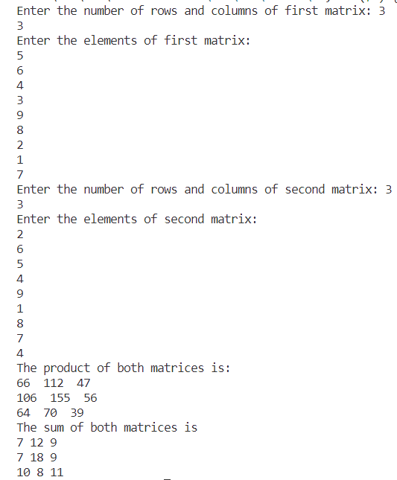

**#7 Write a C++ program to count and display positive, negative, odd and even numbers in an array.**

This is the required program:

#include <iostream>

using namespace std;

int main()

{

    int i, n, j, cp = 0, cn = 0, ce = 0, co = 0;

    cout << "Enter the number of elements of array: ";

    cin >> n;

    cout << "Enter the elements of the array\n";

    int arr[n], parr[n] = {0}, narr[n] = {0}, oddarr[n] = {0}, evenarr[n] = {0};

    for (i = 0; i < n; i++)

            cin >> arr[i];

    for (i = 0; i < n; i++)

    {

        if (arr[i] > 0)

        {

            cp++;

        }

        else

        {

            cn++;

        }

        if (arr[i] % 2 == 0)

        {

            ce++;

        }

        else

        {

            co++;

        }

    }

    cout << "Total positive numbers are: " << cp;

    cout << "\nTotal negative numbers are: " << cn;

    cout << "\nTotal even numbers are: " << ce;

    cout << "\nTotal odd numbers are: " << co;

}

And this is the result:

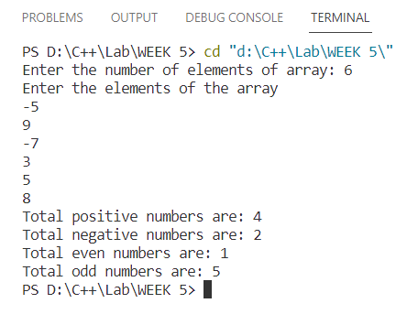

**#8 Write a C++ program to merge two sorted arrays into another array in sorted order.**

This is the required code:

#include <iostream>

using namespace std;

int sort(int arr[], int len)

{ // sorting logic

    for (int i = 0; i < len; i++)

    {

        for (int j = i + 1; j < len; j++)

        {

            if (arr[i] < arr[j])

            {

                int x = arr[i];

                arr[i] = arr[j];

                arr[j] = x;

            }

        }

    }

    return arr[len];

}

int main()

{

    int m, n, x;

    cout << "Enter the number of elements of the array 1\n";

    cin >> m;

    int ar1[m];

    cout << "Enter the elements of array 1\n";

    for (int i = 0; i < m; i++)

            cin >> ar1[i];

    ar1[m] = sort(ar1, m);

    int mergArray[m + n] = {0};

    for (int i = 0; i < m; i++)

           mergArray[i] = ar1[i];

    cout << "Enter the number of elements of the array 2\n";

    cin >> n;

    int ar2[n];

    cout << "Enter the elements of array 2\n";

    for (int i = 0; i < n; i++)

        cin >> ar2[i];

    ar2[n] = sort(ar2, n);

    for (int i = m; i < n + m; i++)

           mergArray[i] = ar2[i-m];

    cout << "Sorted array 1\n";

    for (int i = 0; i < m; i++)

           cout << ar1[i] << " ";

    cout << "\nSorted array 2\n";

    for (int i = 0; i < n; i++)

           cout << ar2[i] << " ";

    cout << "\nMerged and sorted Array\n";

    mergArray[m+n] = sort(mergArray,m+n);

    for (int i = 0; i < m + n; i++)

           cout << mergArray[i] << "   ";

}

And this the result:

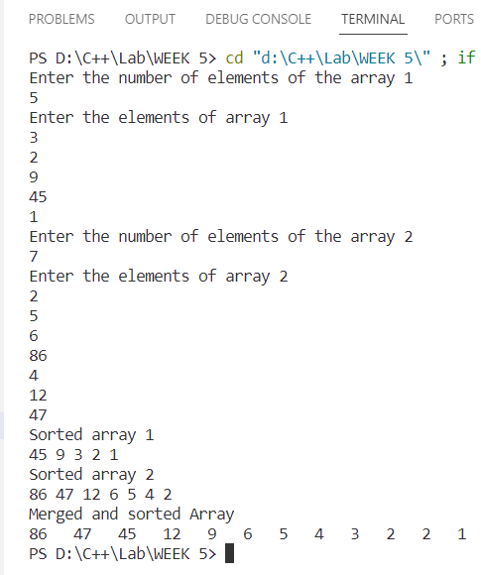

**#9 Write a C++ program to find the frequency of a particular number in a list of integers.**

This the the required code:

#include <iostream>

using namespace std;

int main()

{

    int n, ch, count = 0;

    cout << "Enter the number of element of array\n";

    cin >> n;

    int arr[n];

    cout << "Enter array elements\n";

    for (int i = 0; i < n; i++)

            cin >> arr[i];

    cout << "Enter the number for which you want to check frequency: ";

    cin >> ch;

    for (int i = 0; i < n; i++)

    {

        if (ch == arr[i])

        {

            count++;

        }

    }

    cout<<"The frequency of "<<ch<<" is "<<count;

}

And this is the result:

